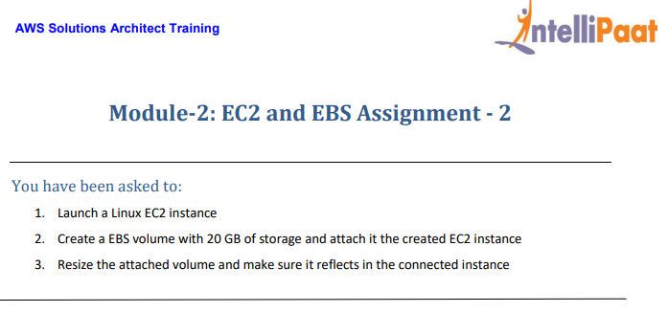

Solution

1. Use the instance created in Assignment 1

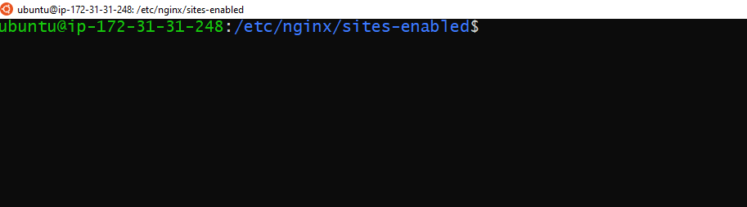

1. Click on ‘Create Volume’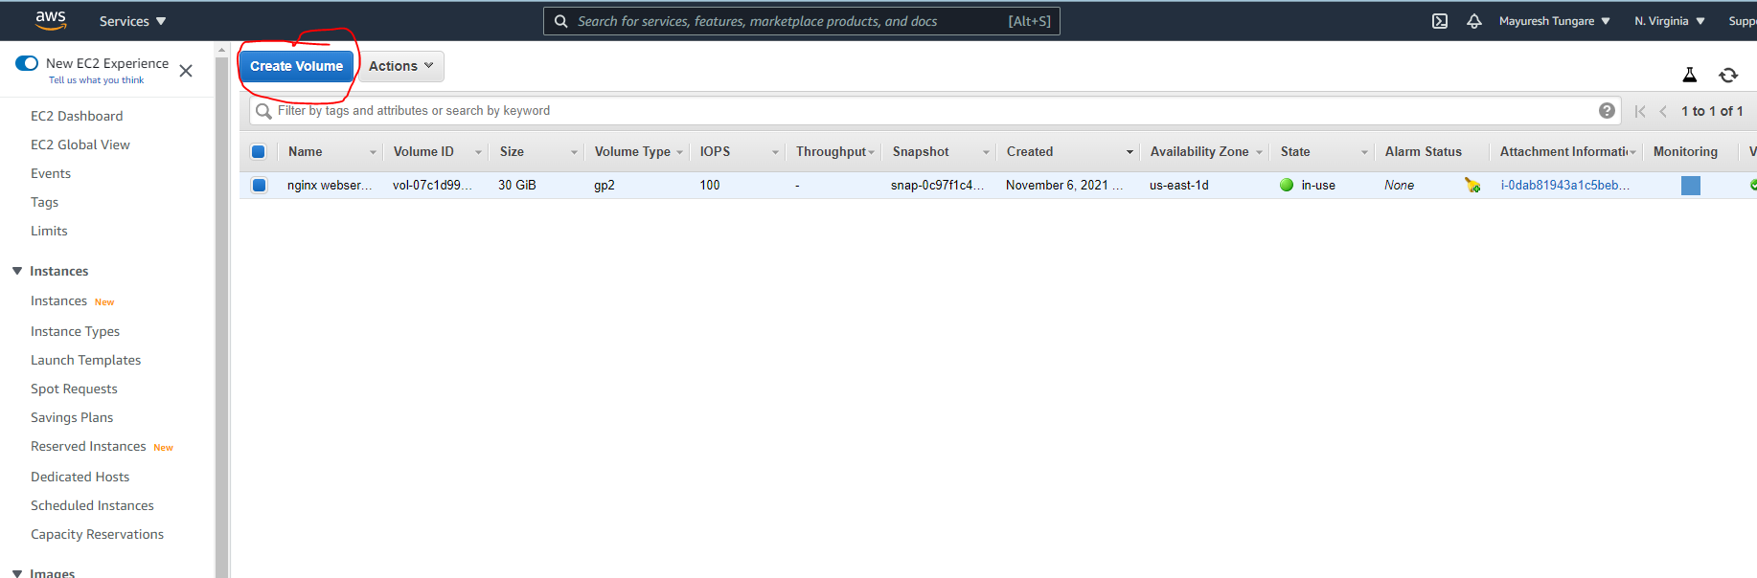
2. Enter the new size (20 GB) for the volume. Also add tags (Key and Value).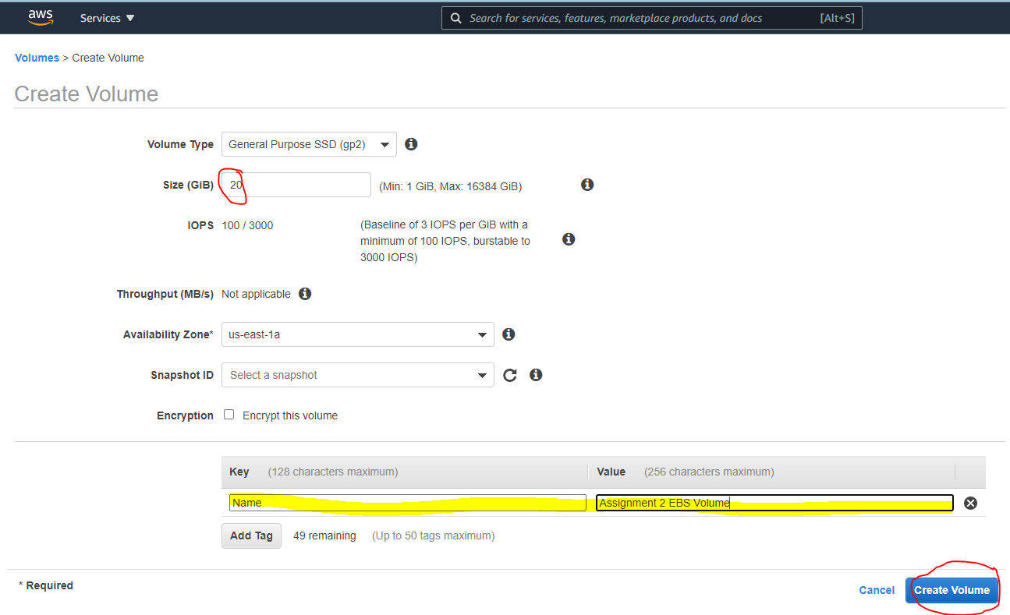
3. You will see the following message that confirms creation of the EBS volume. Note the ID of the new volume.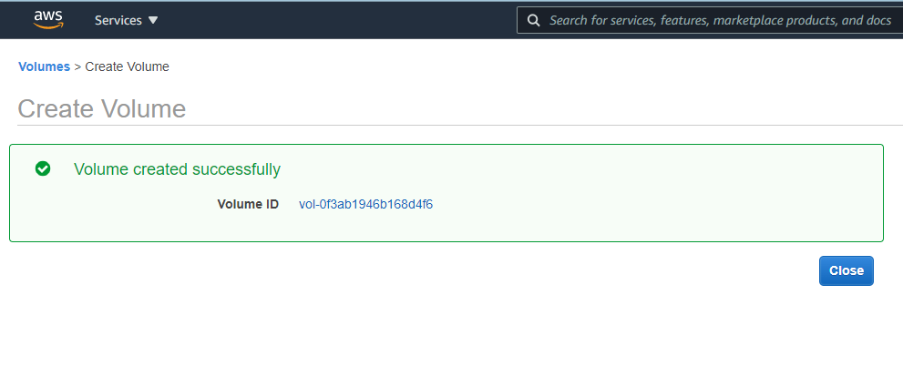
4. The new Volume should now reflect in the Volumes Dashboard (under Elastic Block Store). Click on Actions and then attach Volume.

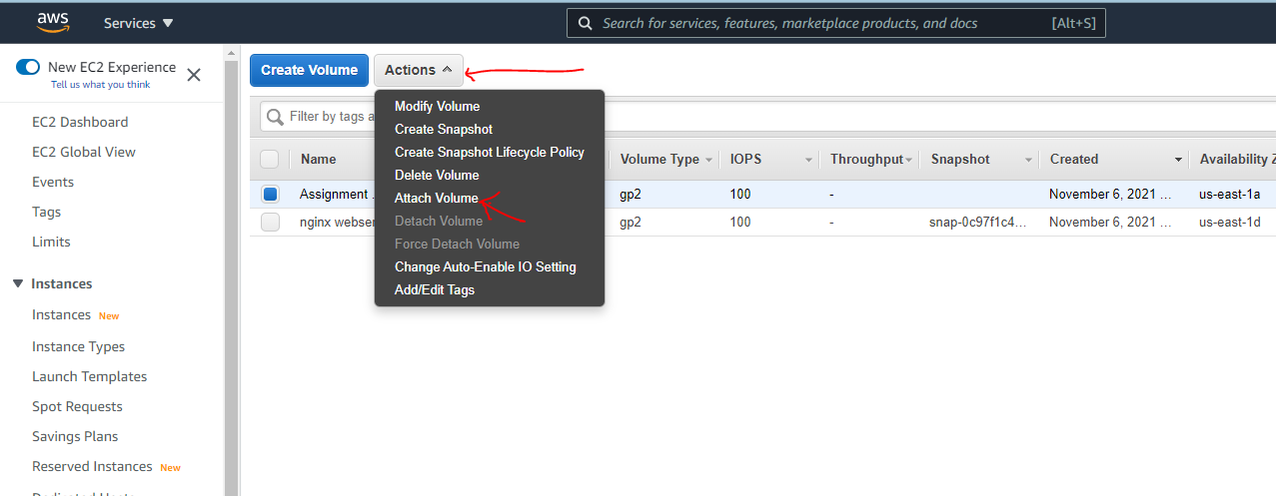

1. It will ask for following details. Enter instance id details to attach it to your EC2 instance.

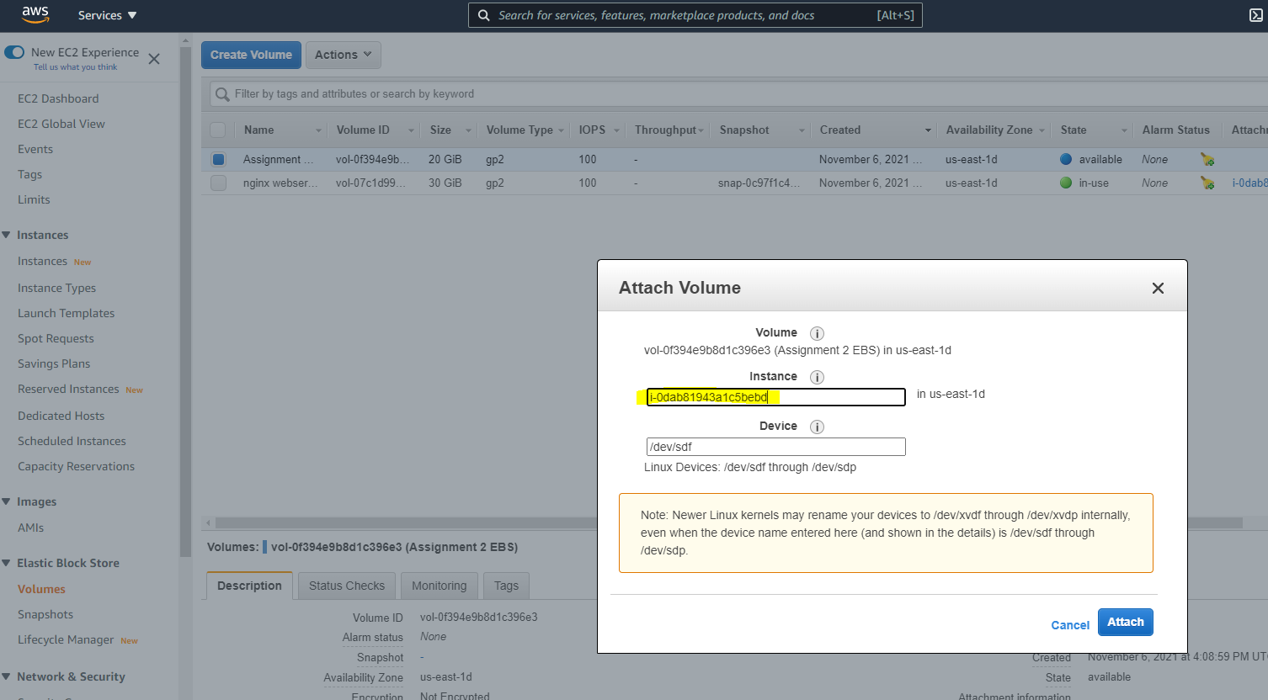

1. The Volume will be attached to the Instance. This can be confirmed from the Volumes Dashboard (they would have the same instance id under attachment information).

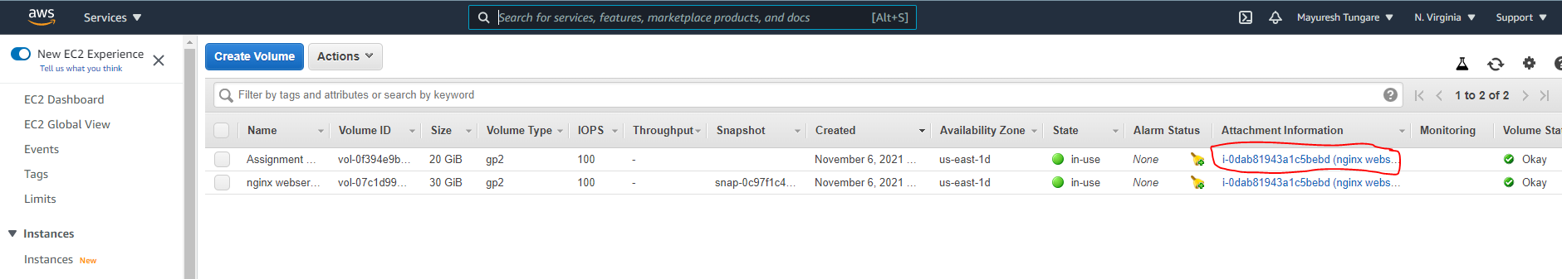

1. Now, we need to modify the size of the volume. For this go to the actions menu and click on modify volume (as shown below).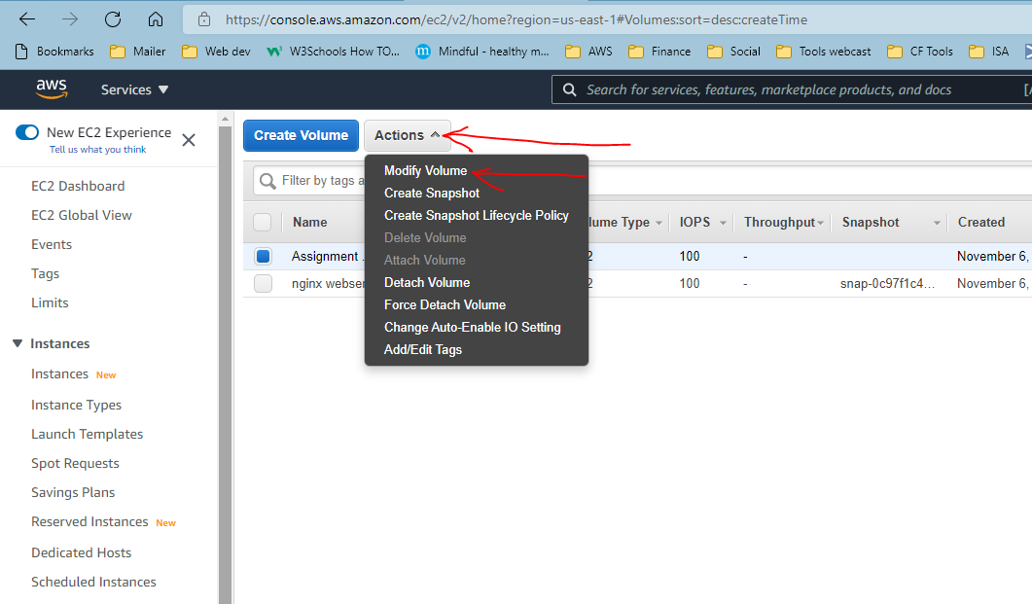
2. Enter new size details as shown below.

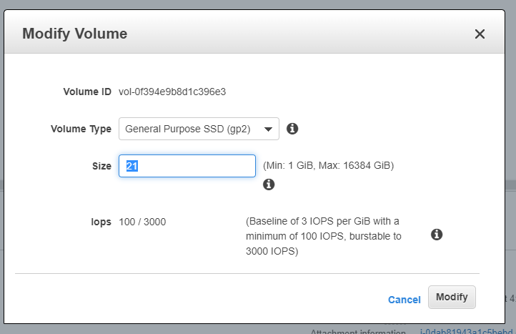

1. Confirm when prompted to check the change.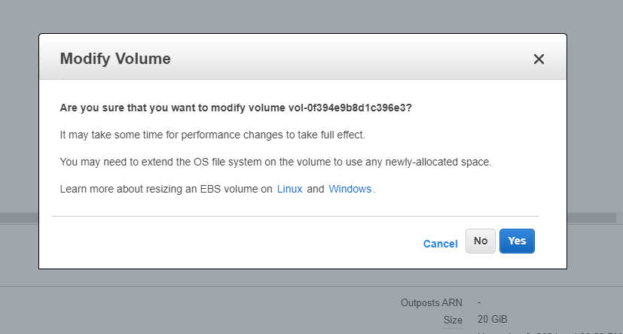
2. After some time, you will see a message confirming that the volume has been modified (message as below).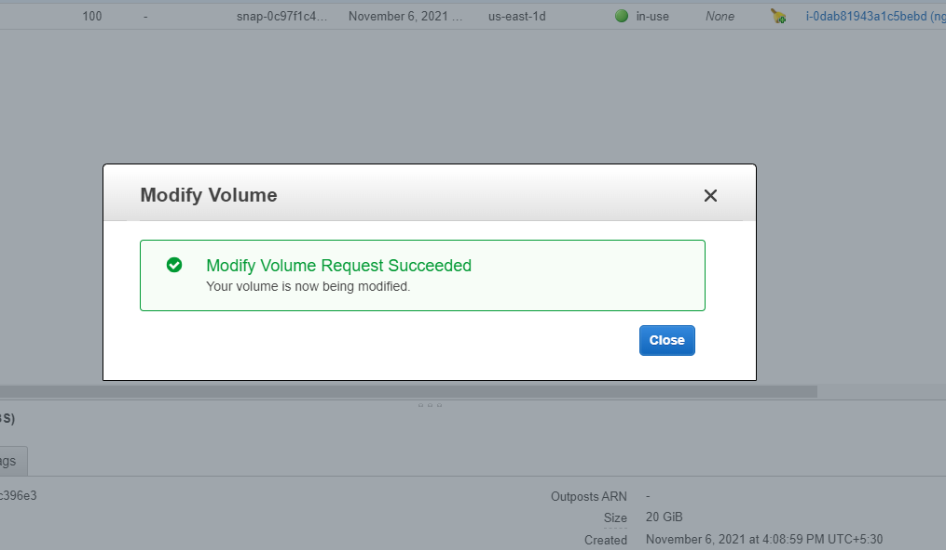
3. You will also be able to confirm this from the Volumes Dashboard (as below).
4. 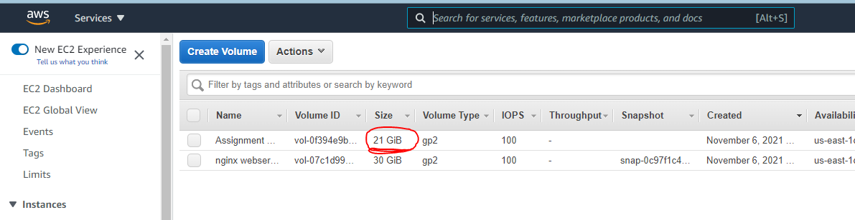
5. With this, assignment 2 is now complete.